Restaurant “La ö” goes big !

Market study of Montpellier, France for franchising a high-end sandwicherie



Contents

Abstract/Executive summary 2

Introduction/Business problem 2

Methodology 2

Research method 3

Required Data 3

Data sources used 3

Data cleaning and preparation rationale 3

Results 5

Descriptive statistics of Montpellier for population and social 5

Conclusion 8

Clustering for similar neighbourhood for service, shops and industries 8

Conclusion 10

Analysis of competitor restaurants with Foursquare 10

Conclusion 11

Discussion 11

Overall conclusion 12

References 12

Acknowledgement 12

Appendix 13

Montpellier open data files 13

# Abstract/Executive summary

Market study to investigate if "La ö" restaurant could be turned out as franchise business into other Montpellier neighbourhoods.

# Introduction/Business problem

Two very good friends of mine, Laura and Denis, are hosting a very good and high-end "fast" food restaurant in Montpellier, France. You can get more detail on the venue and the delicious meals they propose daily (all homemade!) on their facebook account. The restaurant is located in the ArtFx special effects school premises and propose lunch and snacks to students and white-collar people of the surroundings. If you go to this city, feel free to drop yourself there and tell to Laura that you got this address from Elisabeth and Christophe of Zoufftgen. (ask for the Poutine meal...)

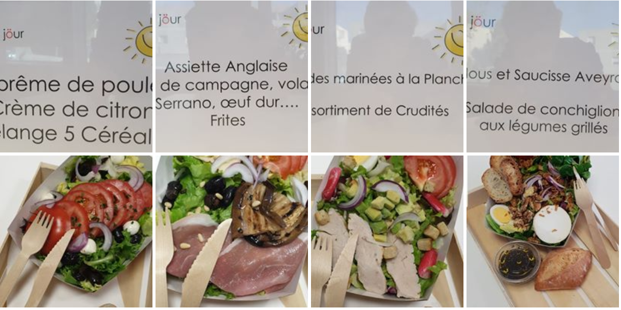

<https://www.facebook.com/restaurant.la.o/> , <https://artfx.school/>

In order to pursue their adventure, Laura and Denis would be interesting to see if restaurant "La ö" could be turned out as a franchise restaurant business. Hence, answer to some questions may help them to see if it worth the pain:

* Where do we find neighbourhoods in Montpellier that are similar to the one where the restaurant "La ö" is currently located? (in term of inhabitants, working customer, business offices and venues)
* What are the competitors that they may face in that similar neighbourhood?
* What are the ratings of those competitors compared to the ones of "La ö"?

# Methodology

We will use unsupervised Machine Learning (ML) clustering to find Montpellier neighbourhood that are similar to the one of restaurant "la ö". We will display those on a map for a preliminary overview. Then we will focus on the competitors: to identify them, we will do a supervised classifier model. Then we would compare their rating with the ones of "La ö". We will display that with regular graph.

All data and maps displayed into this document are available in the related Jupyter notebook:

Restaurant "La ö" goes big - IBM Watson Studio : <https://dataplatform.cloud.ibm.com/analytics/notebooks/v2/017b7cbd-6c7f-40d8-b58b-2442a9e6af2e/view?access_token=d45e0dca5aefd67d94d6f206d1cd5334484fa1a1f1198b332f283d45850f19c2>

## Research method

The following stages will be done in cascade:

* Stage 1: Identify the neighbourhood and their socio-economic data
  + Digest socio-eco data of each neighbourhood and sub-neighbourhood :
  + Create a choropleth map
* Stage 2: Cluster (ML) the neighbourhoods to find the most interesting ones for another restaurant installation
  + Clustering of neighbourhoods regarding the activities, services and shops available
* Stage 3: Find competitor venues description from public datasources
  + Select a subset of neighbourhoods and find the venues that are actually competitors using Foursquare
* Stage 4: Compare with competitors
  + Look for the customer ratings of those venues

*Some stages may be shorten or bypassed due to the lack of data or technical impediments that would make this Capstone last a few month instead of a few days. ☺*

## Required Data

* Geographic and demographic data of montpellier neighbourhoods.
* Socio-economic data of montpellier neighbourhoods.
* List of venues in Montpellier including their category and ratings.

## Data sources used

* OpenData Monpellier (https://data.montpellier3m.fr/): demographic data, geographic data, socioeconomic data of each neighbourhood
* FourSquare API : venues and rating data
  + Unfortunately Foursquare data source does not include a lot of other venues in Montpellier.

## Data cleaning and preparation rationale

Reaching the **open data portal of Montpellier** enables to get the following useful data:

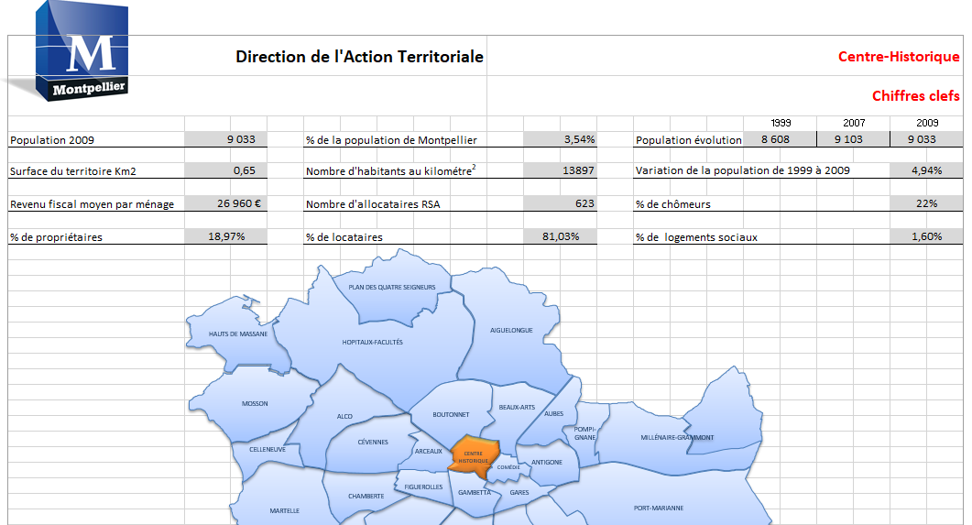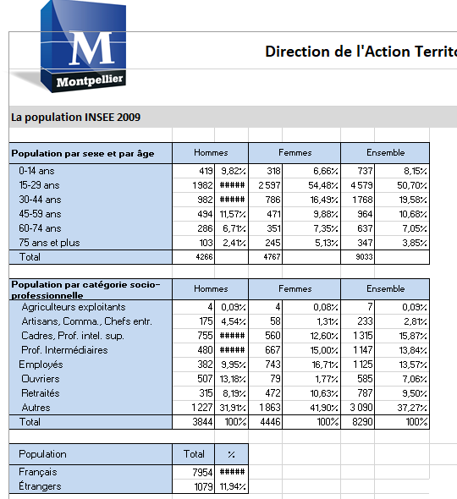

Figure 1 Montpellier open data xlsx

* List of the neighbourhood (“sous-quartier”) of Montpellier and their location ( lat/log), perimeter and area size. It includes also the geojson to help doing Choropleth maps.
* Socio economic data or each neighbourhood are also available (there is one file per neighbourhood):
  + 'Population in 2009','NumberInhabitantskilometer2'
  + 'TerritorySurface', 'number of Flats', 'Number of house ',
  + 'Income Per Inhanbitant',
  + 'Percentage of Landowners'/'Percentage of Tenants'
  + 'NumberSocialMinimumIncome'
  + 'Percentage Unemployed'
  + 'PercentageRentControlledHousing'
  + Population age split:'0-14years'/'15-29years'/'30-44years'/'45-59years'/'60-74years'/'75+years'
  + Population profession split
  + Population nationality split: French or other
  + Household split : number of persons
  + Family size
  + Tenants with state allocation
  + Working In Montpellier/ Outside Montpellier
* **Economic activity data**
  + Number and type of shops
  + Number and type of private services (gaz station, shops….)
  + Number and type of state services(Police station …)
  + Number and type of industries

All those data are cleaned-up and prepared as xlsx files. I used Google Map, ‘Search Nearby’ option to get the centre coordinates of the each neighbourhoud.

Since 2001, Montpellier has been divided into seven official neighbourhoods, themselves divided into sub-neighbourhoods. For our analysis we used the granularity “sous-quartier” that we will call neighbourhood. There are 31 of them, namely:

|  |  |  |
| --- | --- | --- |
| * Aiguelongue * Aiguerelles * Alco * Antigone * Boutonnet * Celleneuve * Centre Historique * Comédie * Croix d'Argent * Estanove * Figuerolles * Gambetta | * Gares * Grammont * Hopitaux-Facultés * La Chamberte * La Martelle * La Pompignane * Lemasson * Les Arceaux * Les Aubes * Les Beaux - Arts * Les Cevennes | * Les Hauts de Massane * Millénaire * Mosson * Pas du Loup * Plan des 4 Seigneurs * Port Marianne * Près d'Arènes * Saint Martin |

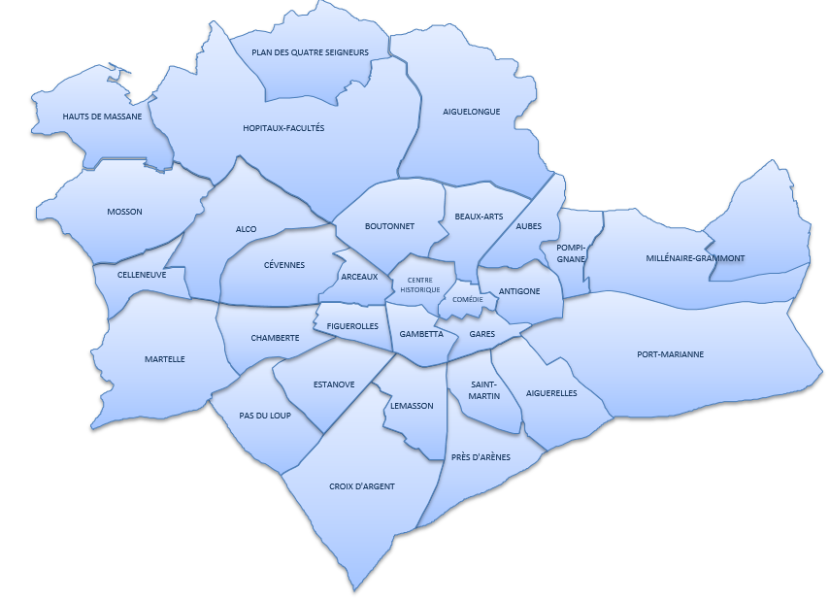

Figure 2 Neighbourhood of Montpellier, France

Using the Foursquare API, we are able to get the venues list and category of each neighbourhood using a central longitude/latitude point for the neighbourhood area and a radius of 2 km as lookup surface. Only categories related to “restaurant” were selected.

# Results

## Descriptive statistics of Montpellier for population and social

The restaurant “La ö” is located in the neighbourhood “Hopitaux-Facultés” which is the largest of Montpellier after “Port Marianne” and just before “Aiguelongue”.

Let’s compare this neighbourhood with the others. “Hopitaux-Facultés” population is the largest by far. Its population is mostly young and between 15-29 years old. The segment 30-44years is also large. So we can assume that its 27,726 inhabitants are mostly active.

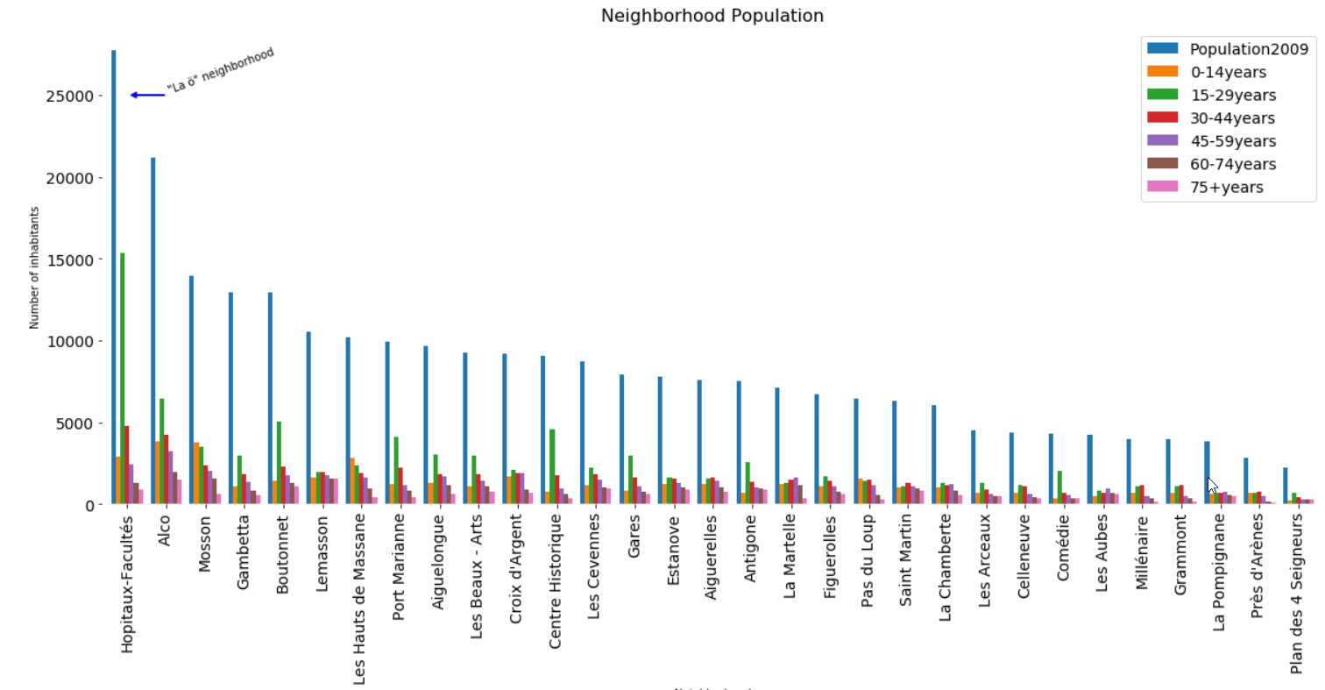

No other neighbourhood have such a high rate of young population. This might be due to the fact that many students may be living nearby universities and schools.

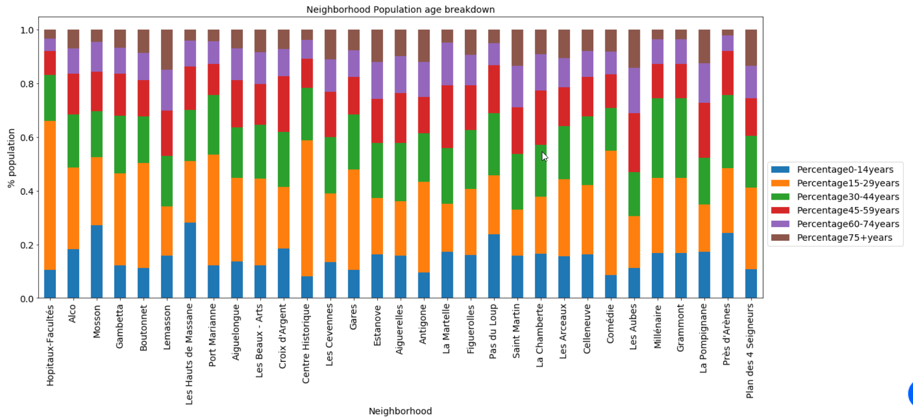

When looking at the profession of inhabitants in each neighbourhood we see that “Hopitaux-Facultés”, “Alco” and “Boutonnet” have the highest rate of “autres” aka “other”. This category includes the “student” category. This can be explained by the fact that all student take accommodation nearby the area where universities and schools is located.

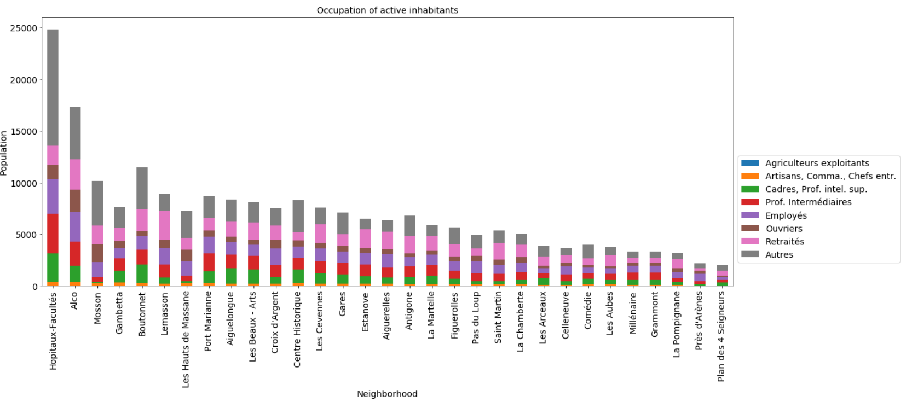

Regarding the social care, we see that in neighborhood “Hopitaux-Facultés” almost 12,000 out of 25,000 which is large receive a state housing allowance. You have to know that in France, students or people with low income or jobless receive money from the state to help paying accommodation. Here we see that almost 50% receive an allowance. This is a marker that many people are students as usually students receive an accommodation allowance during their study.

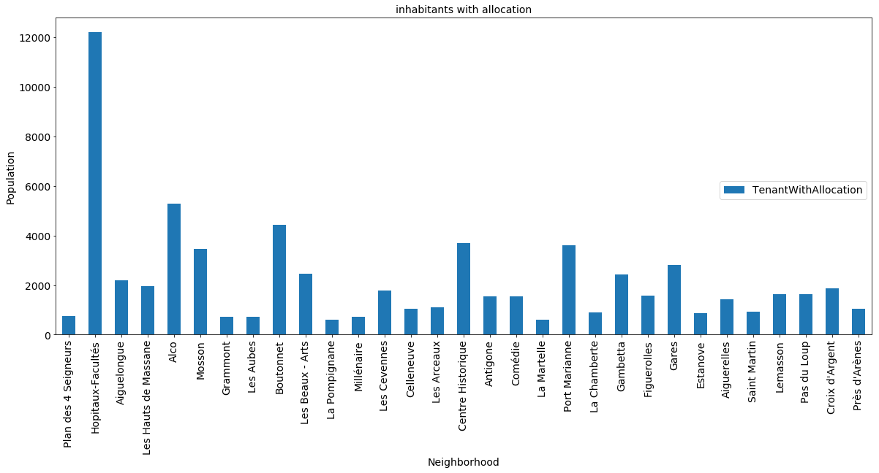

Income per inhabitant of each neighbourhood would help to identify what is the wealth population hence the probability that they go out to have diner or lunch and which kind of restaurant they can afford. I used python folium library to visualize geographic.

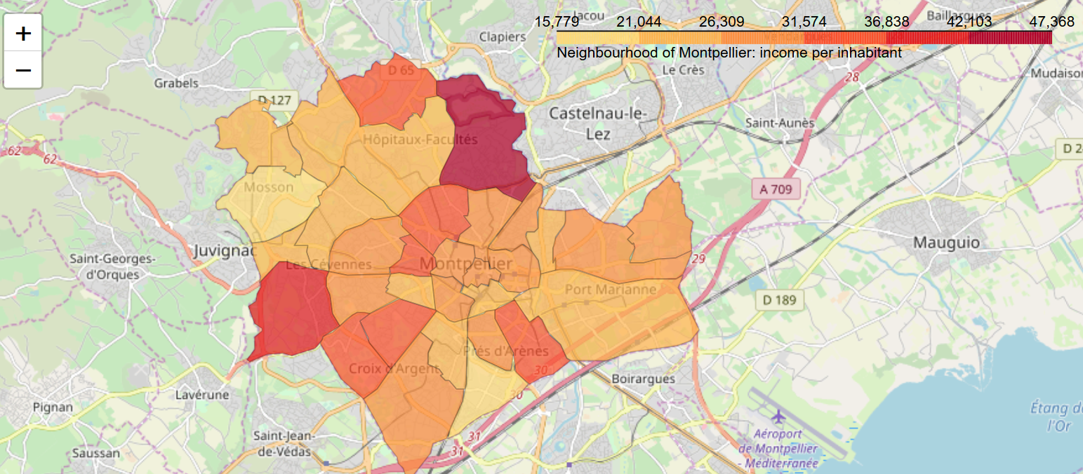

Figure 3 Income per inhabitant

We see clearly that the income per inhabitant of the neighbourhood “Hopitaux-Faculté” is one of the lowest of Montpellier. It could be that inhabitants are students or lower/mid-class workers whose jobs are into public institutions such as hospital/public university or into private service companies.

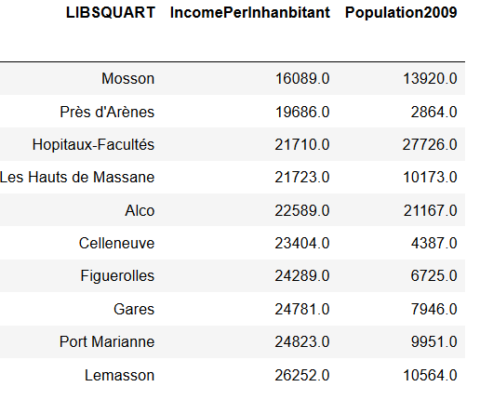

Figure 4 Lowest 10 income per capita

Neverleless the neighborhood is located nearby the richest one “Aiguelongue”. This is most probably, where high-level white collars live. They could commute to work every day and have their home in a nice environment.

Regarding the business activities, we can see the “Hopitaux-Facultés” is among the ones with the largest number of “enseignement” (aka teaching) institution. But there are unfortunate bias here as elementary schools and college are accounted. Same regarding the “scientific activities” as they are into the same category as “administrative service”. The history centre certainly includes many “local” administrative services such as city hall etc.

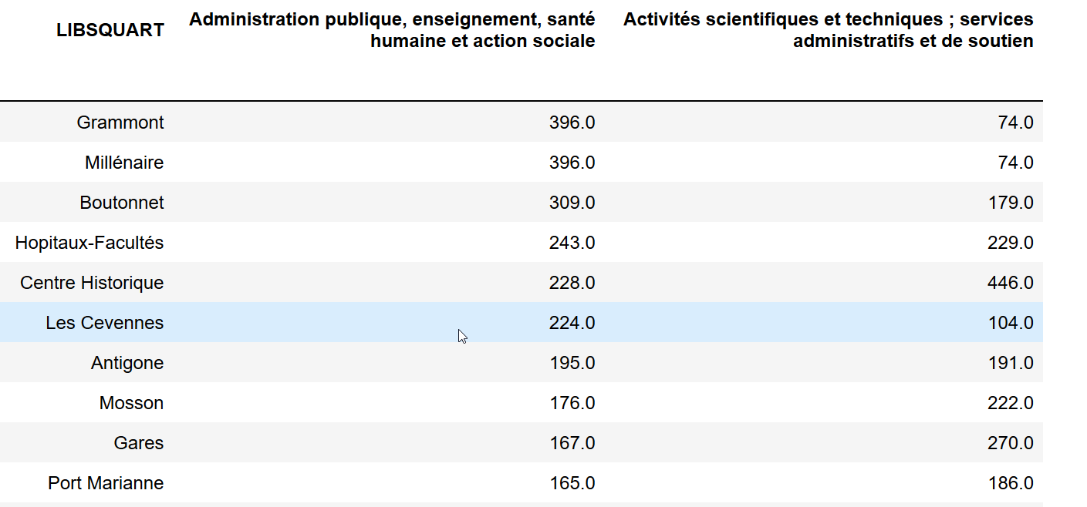

Figure 5 Number of institution by domain

Regarding the venues in Montpellier, there are a lot of them spread all around and into the city with no specific location pattern that we can identify.

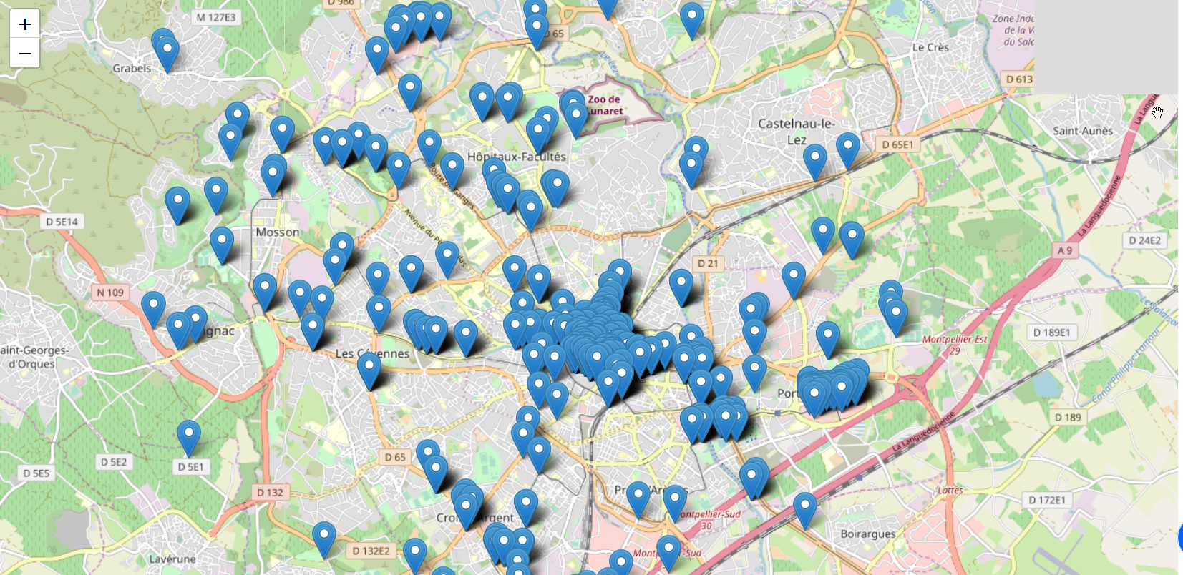

Figure 6 Venues in Montpellier as provided by Foursquare

### Conclusion

Because «Restaurant La ö» is a fast food (even high end) it is more relevant to settle its business into a middle class or working-class neighbourhood. Based on the above statistics on population and social indicators, we would elect the following neighbourhoods:

* Alco, Mosson, Gambetta : because of the age and profession of inhabitant (including students)
* Mosson, Alco, Près d’Arène, Les haut de Massane, Celleneuve : because of the income per capita

## Clustering for similar neighbourhood for service, shops and industries

We can also cluster the neighbourhoods based on key indicators so that we can identify which other neighbourhoods have similar “business” as the one were restaurant “La ö” is located. We use a KMeans algorithm as it is lean and simple to implement and is one of the most common cluster method of unsupervised learning.

The following key indicators are used to feed the clustering Machine Learning algorithm. It counts the number of industries, shops or services among different categories.

|  |  |  |
| --- | --- | --- |
| Industries:  'Industries extractives, énergie, eau, gestion des déchets et dépollution',  'Fabrication de denrées alimentaires, de boissons et de produits à base de tabac',  'Fabrication équipements électriques, électroniques, informatiques ; fabrication de machines',  'Fabrication de matériels de transport',  'Fabrication autres produits industriels',  'Construction',  'Commerce ; réparation dautomobiles et de motocycles',  'Transports et entreposage',  'Hébergement et restauration',  'Information et communication',  'Activités financières et dassurance:',  'Activités immobilières',  'Activités scientifiques et techniques ; services administratifs et de soutien',  'Administration publique, enseignement, santé humaine et action sociale',  'Autres activités de services',  'Établissements sans salariés',  'Établissement de 1 à 49 salariés',  'Établissements de 50 salariés et +', | Shops :  'Hypermarché',  'Supermarché',  'Grande surface de bricolage',  'Supérette',  'Epicerie',  'Boulangerie',  'Boucherie charcuterie',  'Produits surgelés',  'Poissonnerie',  'Librairie papeterie journaux',  'Magasin de vêtements',  'Magasin déquipements du foyer',  'Magasin de chaussures',  'Magasin délectroménager et de mat. audio-vidéo',  'Magasin de meubles',  'Magasin darticles de sports et de loisirs',  'Magasin de revêtements murs et sols',  'Droguerie quincaillerie bricolage',  'Parfumerie',  'Horlogerie Bijouterie',  'Fleuriste',  'Magasin doptique',  'Station service', | Services :  'Police',  'Trésorerie',  'Gendarmerie',  'Cour dappel',  'Tribunal de grande instance',  'Tribunal dinstance',  'Conseil de prud’hommes',  'Tribunal de commerce',  'Agence de proximité',  'Relais pôle emploi',  'Permanence pôle emploi',  'Agence de services spécialisés',  'Agence thématique',  'Banque, Caisse dépargne',  'Pompes funèbres',  'Bureau de poste',  'Relais poste commerçant',  'Agence postale communale',  'Réparation auto et de matériel agricole',  'Contrôle technique automobile',  'Location auto-utilitaires légers',  'École de conduite',  'Maçon',  'Plâtrier peintre',  'Menuisier, charpentier, serrurier',  'Plombier, couvreur, chauffagiste',  'Électricien',  'Entreprise générale du bâtiment',  'Coiffure',  'Vétérinaire',  'Agence de travail temporaire',  'Restaurant',  'Agence immobilière',  'Blanchisserie-Teinturerie' |

Example of key indicator

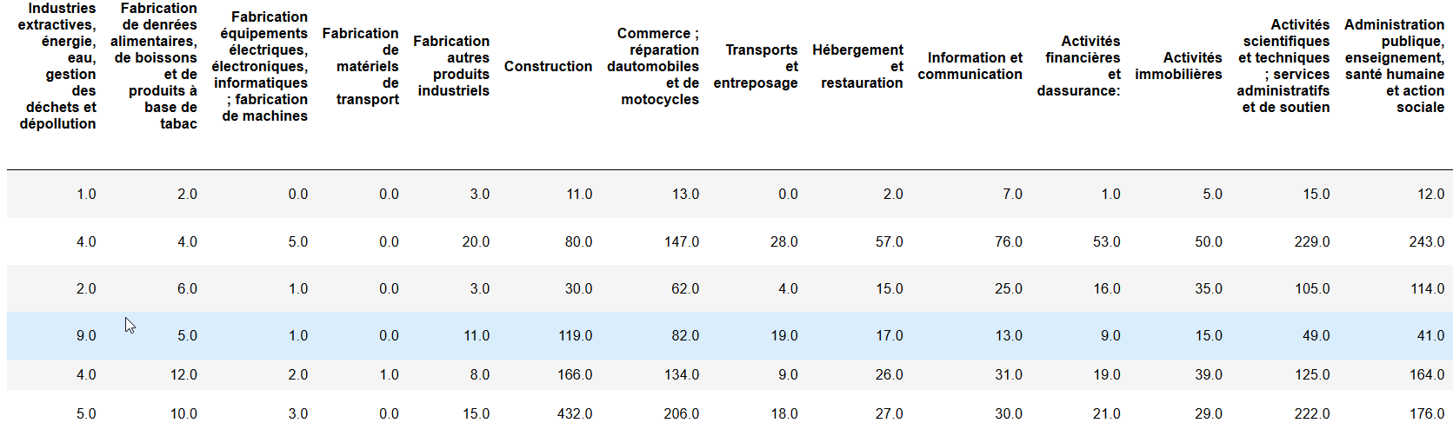

Figure 7 Key indicators for clustering

The selection of the number of clusters was made according to the best inertia as shown below

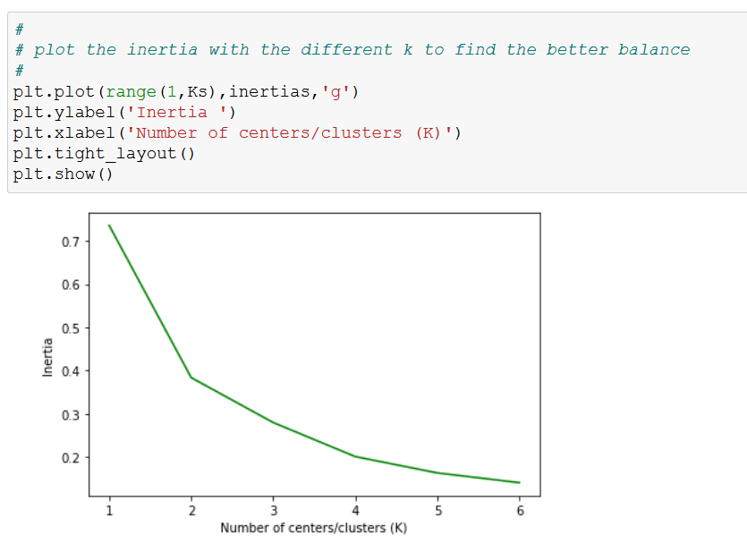

The result of the clustering with 4 centers is displayed in map below.

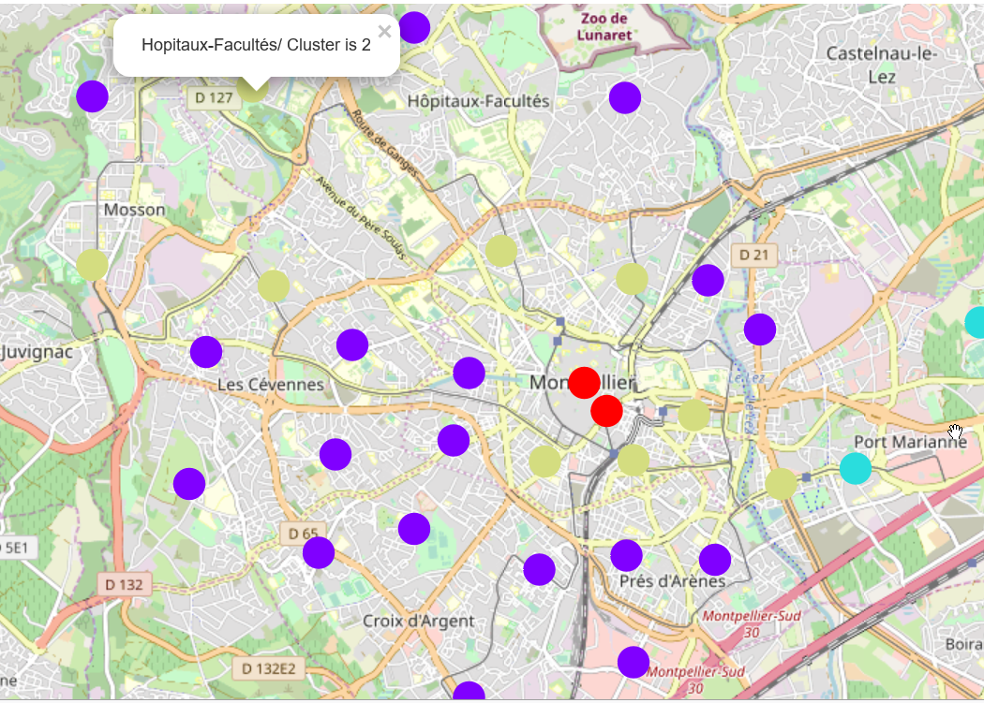

Figure 8 Neighbourhood clustering map

The content of the 4 clusters is given below.

|  |  |  |
| --- | --- | --- |
| Cluster | Number of neighbourhoods | Neighbourhoods |
| 0 | 18 | Plan des 4 Seigneurs, Aiguelongue, Les Hauts de Massane, Les Aubes, La Pompignane, Les Cevennes, Celleneuve, Les Arceaux, La Martelle, La Chamberte, Figuerolles, Estanove, Aiguerelles, Saint Martin, Lemasson, Pas du Loup, Croix d'Argent, Près d'Arènes |
| 2 | 9 | **Hopitaux-Facultés**, **Alco, Mosson, Boutonnet, Les Beaux - Arts, Antigone, Port Marianne, Gambetta, Gares** |
| 3 | 2 | Centre Historique, Comédie |
| 1 | 2 | Grammont, Millénaire |

### Conclusion

We can conclude that based on the available services, shops and industries, 8 neighbourhoods offer the same environment as Hopitaux-Facultés : Alco, Mosson, Boutonnet, Les Beaux - Arts, Antigone, Port Marianne, Gambetta, Gares.

## Analysis of competitor restaurants with Foursquare

Foursquare provides some useful information about restaurant “la ö”. (https://foursquare.com/v/restaurant-la-%C3%B4/5e18de2aa97b28000874c350)

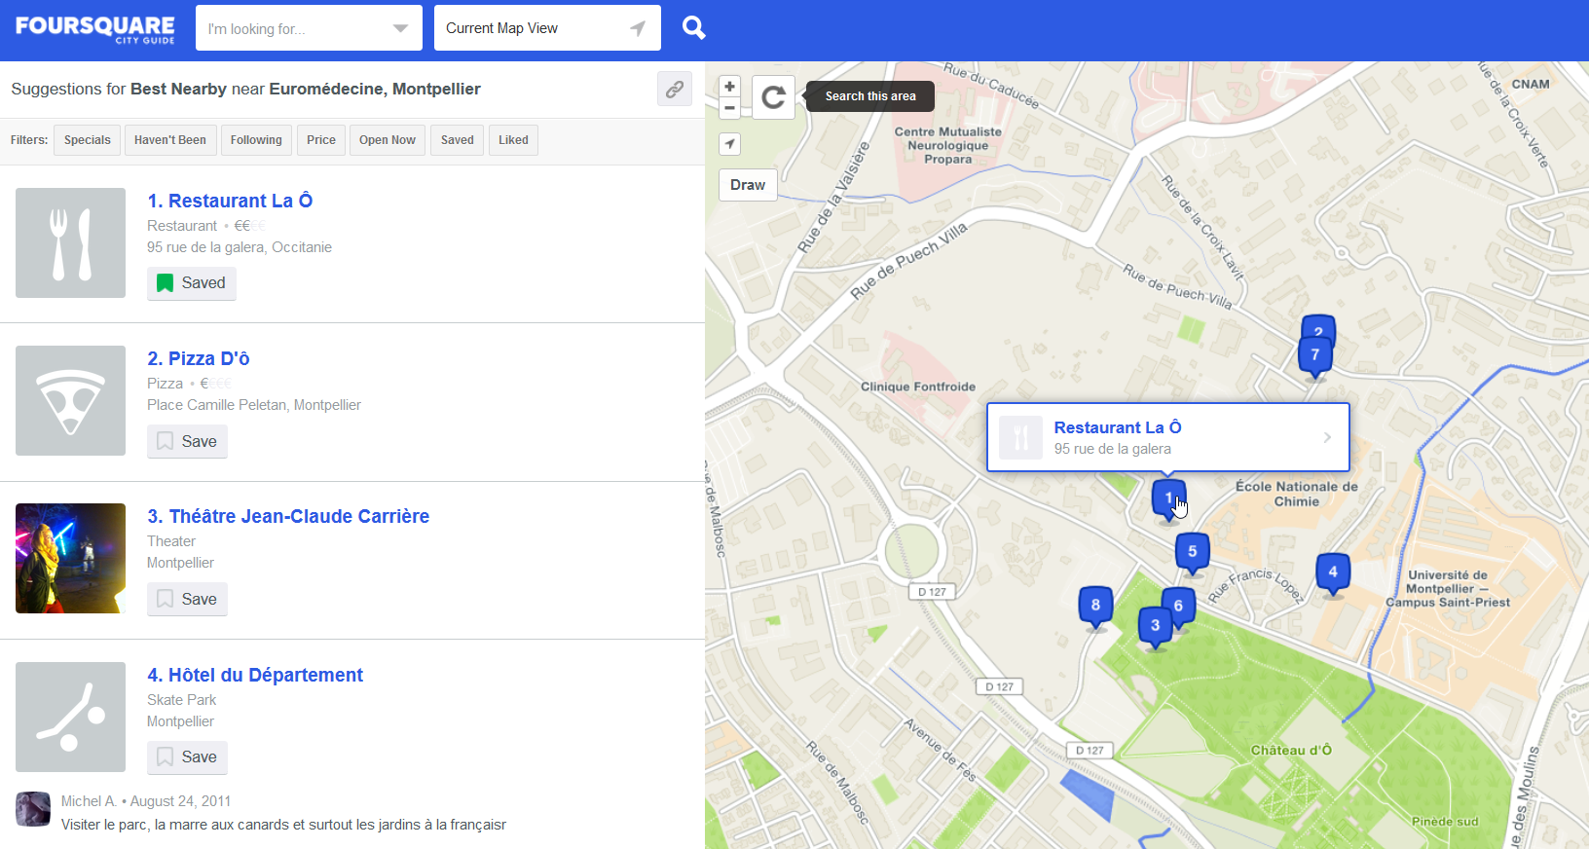

Figure 9 Restaurant "La ö" as displayed by Foursquare website

But what about the competitors that may be already present into the target neighbourhoods? In order to scope our search we will focus on the neighbourhoods that match both the descriptive analytics on population/social and the machine learning clustering that we did in the above chapters: **Alco, Mosson and Gambetta**.

There are 27 restaurants or food related venues in those 3 neighbourhoods:

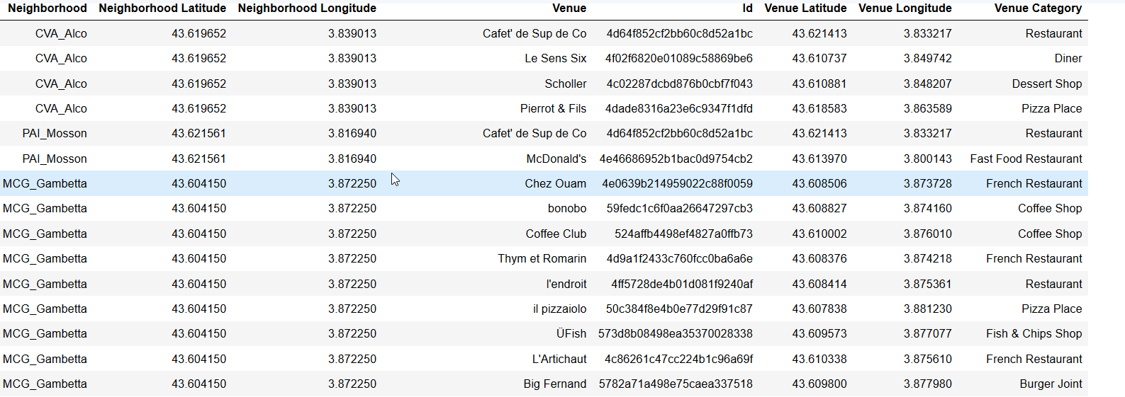

Figure 10 Restaurants in selected neighbourhoods

Here is their localisation

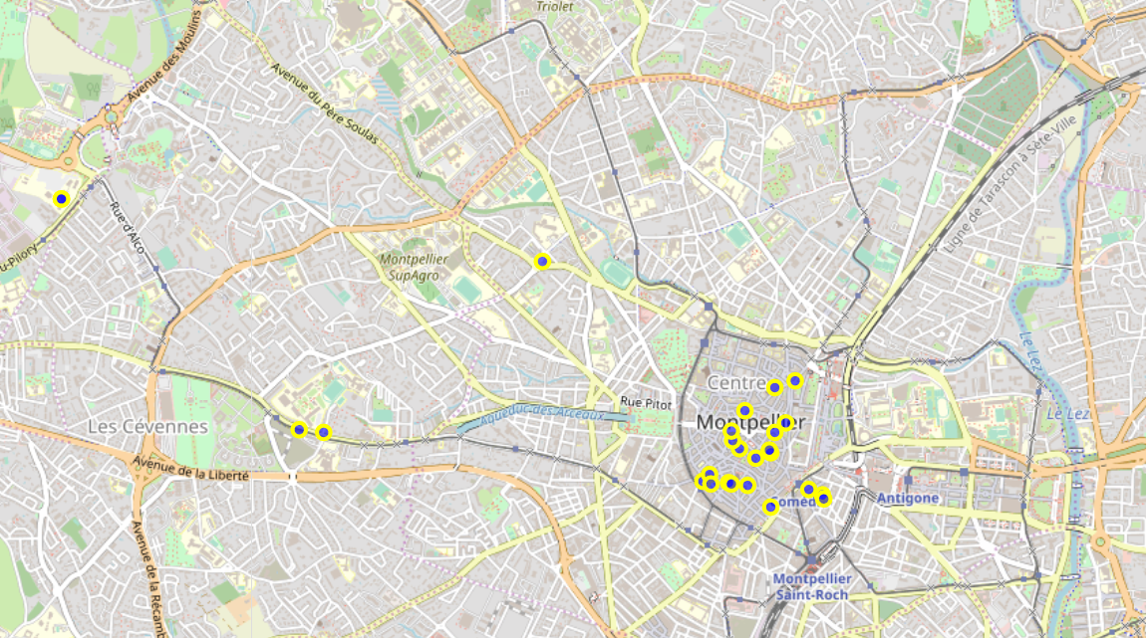

Figure 11 Restaurant location in Alco, Gambetta and Mosson

We see that there are a lot of restaurant in Gambetta. It is not a good idea to go in place where there are already many competitors. So let’s see the rating of the restaurants in the 2 others neighbourhood:

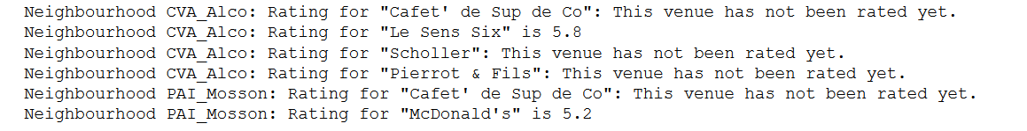

### Conclusion

It is hard to make a decision based on the data from Foursquare. Especially as it is crowd sourced data. Nevertheless, Alco and Mosson neighbourhoods seem to be a good place as there are few restaurants there whose ratings are not that good.

# Discussion

The analysis allows us to identify 2 neighbourhoods where another “La ö” restaurant could be installed. But we faced several impediments to provide a better analysis:

* Foursquare does not populate much of the venues of Montpellier. Some neighbourhood are clearly missing a lot of venues. I tried to reach the Facebook API instead but unfortunately, it seems that we cannot do a search based on latitude and longitude with a radius. Other website such as yelp (<https://www.yelp.fr/montpellier>) may be used as they seem to provide more up-to-date information.
* Population data are rather old (2009)
* Montpellier Open data are very useful indeed but the categories are too high level. For instance, elementary schools and universities are accounted in the same bin.

More over neighbourhood boundaries are purely “geographic” which helps doing statistics but does not reflect the real habits of people and the area they live in.

# Overall conclusion

I would advise my friends, Laura and Denis, to find a location in the neighbourhood “Alco”. It seems a good place as the population and activities are the same as “Hopitaux-Facultés” where their restaurant is currently located. Moreover they will face very few competitors there and there are also a lot of students that may become regular clients. The drawback is that is that this neighbourhood is close to the current one. The bulk of customers may be too small to accommodate two restaurants.

The same analysis would be more useful if done with the neighbourhoods of other cities in France. But this is another story….

# References

- Géolocalisation details (https://perso.esiee.fr/~courivad/Python1/15-geo.html)

- https://data.montpellier3m.fr/

- https://www.insee.fr

- https://www.insee.fr/fr/statistiques/1405599?geo=EPCI-243400017

- https://inhesj.fr/ondrp

- https://www.data.gouv.fr

- <https://france-decouverte.geoclip.fr>

- <https://sig.ville.gouv.fr/>

- <https://wiki.openstreetmap.org/wiki/Montpellier>

- <https://fr.wikipedia.org/wiki/Montpellier_M%C3%A9diterran%C3%A9e_M%C3%A9tropole>

# Acknowledgement

Thanks to my friends Laura and Denis for providing me such a pleasant capstone to do. I hope that it will be helpful for their business!

Thanks to Montpellier for the open data portal. Not all cities in France provide that!

# Appendix

## Montpellier open data files

